Kahoot Quiz | 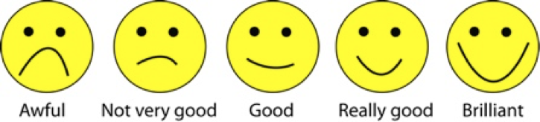
Comments:

Breathlessness Presentation
Comments:

Was an inquiry approach used?
Comments:

Was the content relevant to your practice?
Comments:

Do you have suggestions about how I can improve this class?

